Bastion with ORM Stack

Contents

1. Introduction 2
2. Workflow diagram to deploy the stack 2
3. Create Stack 4
4. Upload the Artifacts 4
5. Plan the Job 6
6. Apply the Job 8
7. Verify in the Console 10
8. Destroy the stack 10

Introduction

This resource provides the Bastion resource in Oracle Cloud Infrastructure Bastion service.
Creates a new bastion. A bastion provides secured, public access to target resources in the cloud that you cannot otherwise reach from the internet. A bastion resides in a public subnet and establishes the network infrastructure needed to connect a user to a target resource in a private subnet.

Bastions are logical entities that provide secured, public access to target resources in the cloud that you cannot otherwise reach from the internet. Bastions reside in a public subnet and establish the network infrastructure needed to connect a user to a target resource in a private subnet . Integration with the IAM service provides user authentication and authorization. Bastions provide an extra layer of security through the configuration of CIDR block allowlists. Client CIDR block allowlists specify what IP addresses or IP address ranges can connect to a session hosted by the bastion.

Bastions is created and managed the sessions that provide authenticated users with ephemeral, timebound access to resources in the tenancy. Bastions establish secure bridge connections from preconfigured IP addresses to supported target hosts that do not have a public IP address, such as compute instances running an OpenSSH server or autonomous transaction processing databases that support SSH tunneling to an arbitrary port.

Workflow diagram to deploy the stack

Below diagram shows how the Terraform Artifact are applied in the OCI. While creating a ORM stack, using terraform deliverables Init, Plan and Apply is the flow to provision the resource in the OCI. We can have the deliverables in any of below.
GitLab/GitHub Repo
Bitbucket
- Can be in folder/.zip in the local disk
- Object Storage Bucket
- Can be in compartment
- Oracle provided Template


Pre-request:
- VCN and public subnet is required

Create Stack

Go to OCI Console Developer Services Resource Manager Stacks select the compartment Create Stack
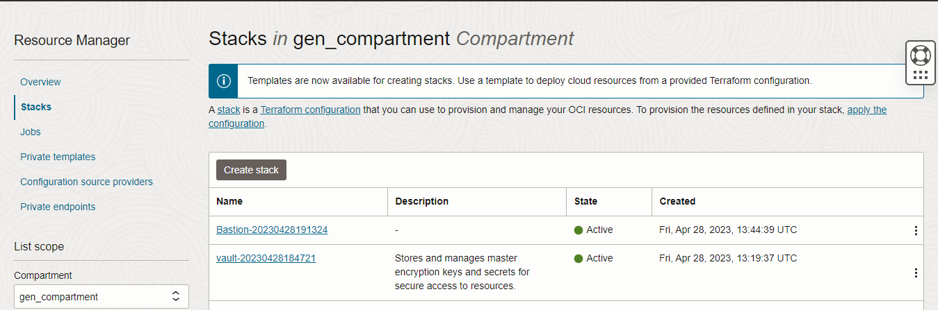

Upload the Artifacts
My Configuration Folder Browse

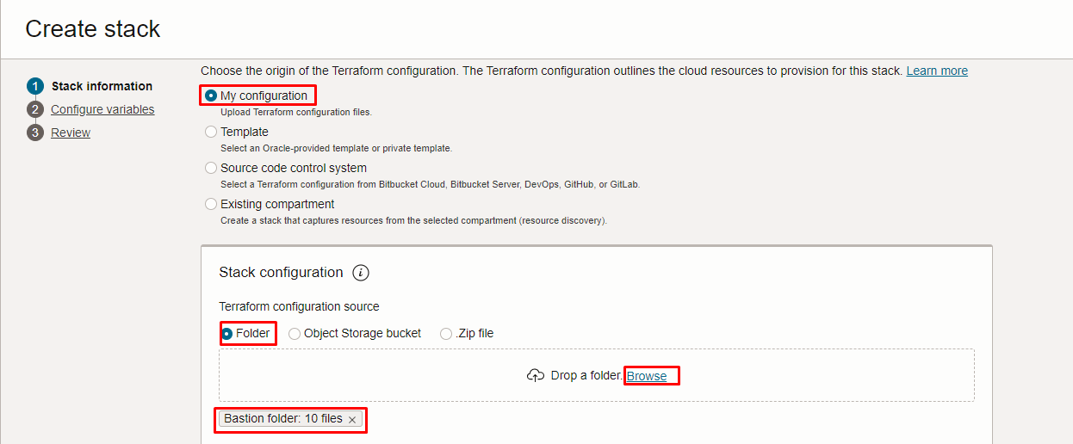

Select the Bastion folder that contains the terraform and yaml Upload
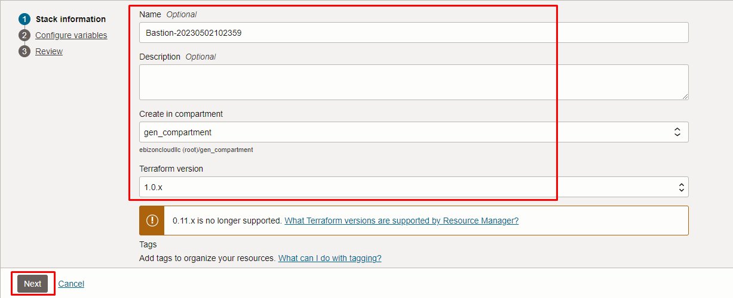

Click “NEXT”
Select the compartment, to create the bastion 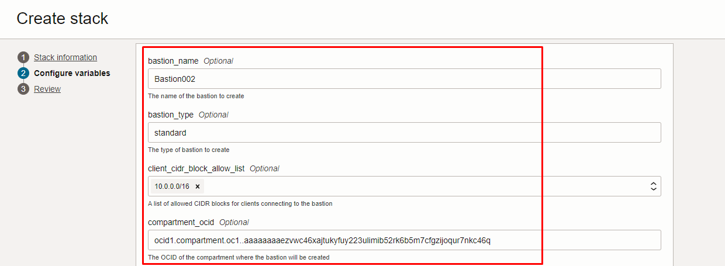

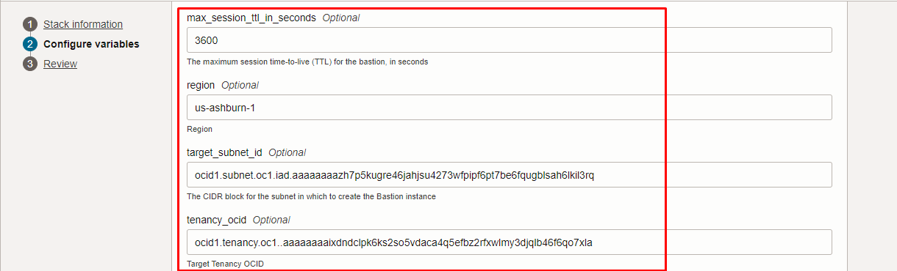

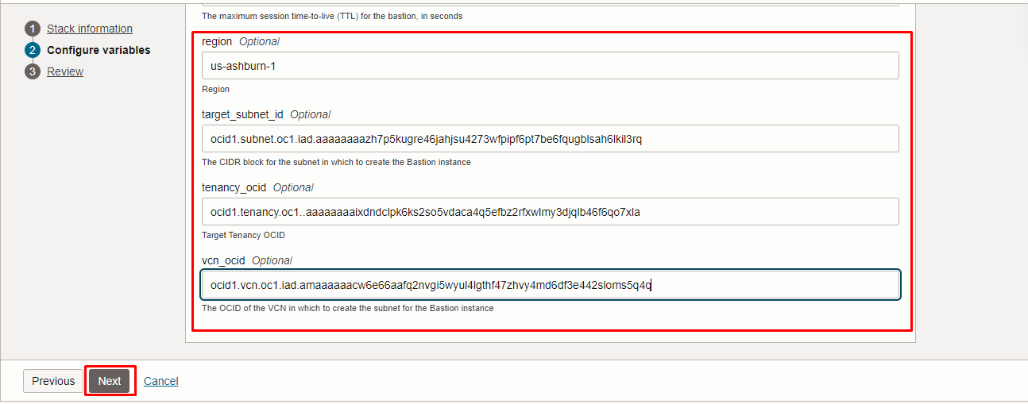

Click “NEXT”

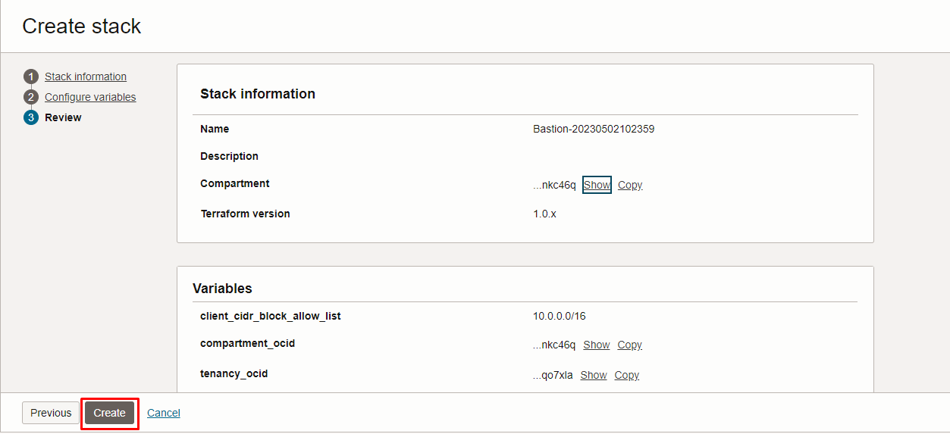

Click “CREATE”

Plan the Job
Click the “Plan”

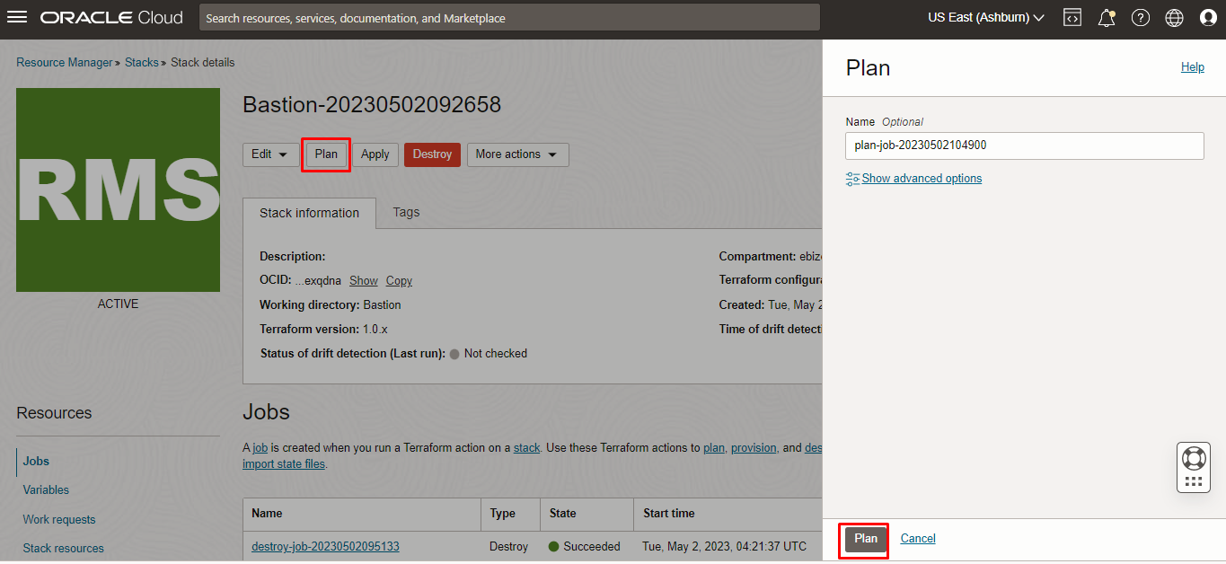

Verify the Plan is successful.

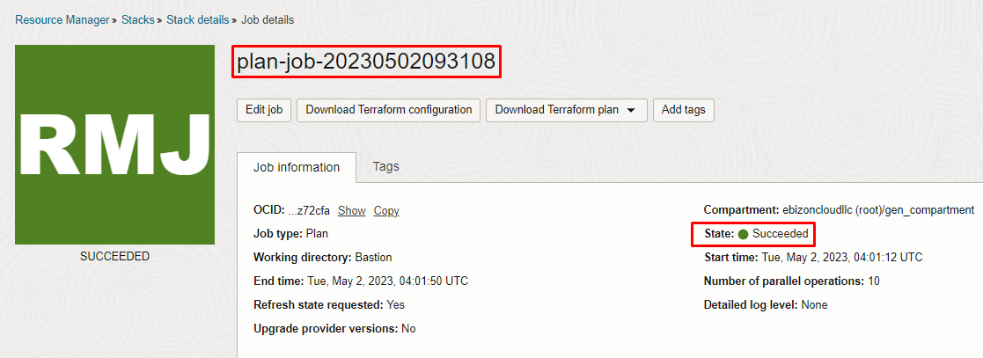

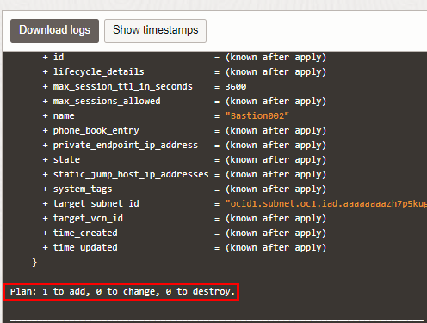

Apply the Job
Once the “plan” is success, now click “Apply”

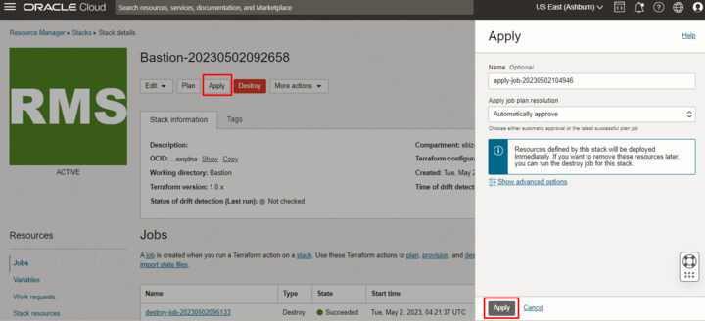

Verify the Apply is successful.

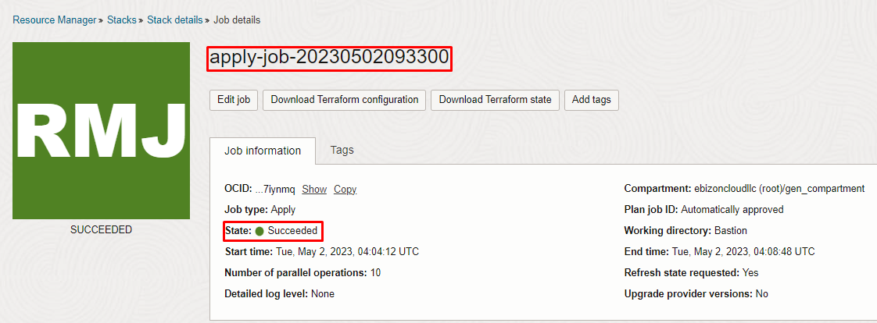

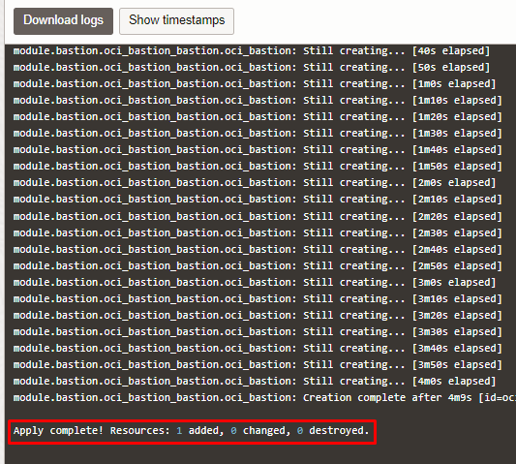

Verify in the Console

Go to OCI Console Identity & Security Bastion

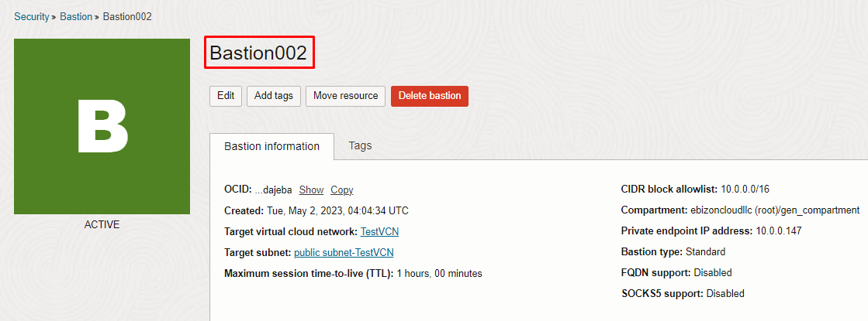

Destroy the stack
Create a destroy job in Resource Manager to release resources associated with a stack and clean up the tenancy. Once destroyed data cannot be recovered from resources.

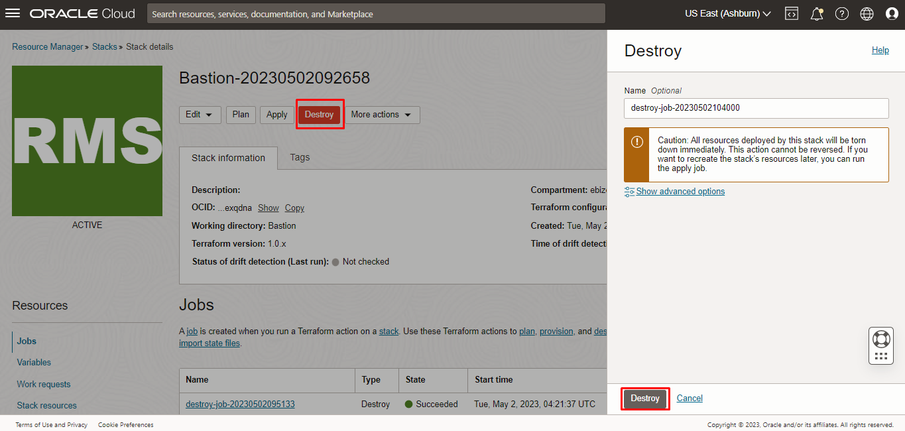

# END #

